Practical: 1.2

Aim : Study of basic Linux commands.
- ls command: Lists the files and directories present in the current directory. ls command options:
ls -l : long listing format ls -a : show hidden files
ls -h : human-readable file sizes ls -R : recursive listing
ls -t : sort by time ls -r : reverse order ls -S : sort by size
ls -i : display inode number ls -d : list directories only

Output:
[24ce102@localhost ~]$ ls os1 OS31
[24ce102@localhost ~]$ ls –l total 8
-rw-r--r--. 1 24ce8 domain users 12 Jan 6 12:52 os1
-rw-r--r--. 1 24ce8 domain users 8 Jan 6 12:41 OS31
drwxr-xr-x. 2 24ce8 domain users 6 Jan 6 13:00 P
- cat command : It is used to display, create, and combine (concatenate) files.

cat command options:
cat > filename : creates a new file
cat >> filename : append content to an existing file

Output:

[24ce102@localhost ~]$ cat > os1 A

B C D

[24ce102@localhost ~]$ cat >> os1 E

F

- bc command : It stands for Basic Calculator and it supports integer, floating-point, and arithmetic operations.
bc command : bc

Output :
[24ce102@localhost ~]$ bc 2*3+5
11
scale = 3 2*3/8
.750
sqrt(125) 11.180
x=3 y=4 z=5 x+y+z 12
x=3;y=4
x*y 12

- script command : It is used to record everything that happens in a terminal session.

Output :

- who command : It is used to display information about users who are currently logged into the system.

Output :
[24ce102@localhost ~]$ who (clients logged in on the server at that time) 24ce16 pts/3 2026-01-06 12:36 (F2T7.SVITVASAD.LOCAL)
24ce72 pts/0 2026-01-06 12:37 (F2T3.SVITVASAD.LOCAL)
24ce118 pts/10 2026-01-06 12:37 (F2T15.SVITVASAD.LOCAL)
24ce136 pts/11 2026-01-06 12:37 (F2T6.SVITVASAD.LOCAL)
24ce47 pts/7 2026-01-06 12:46 (F2T4.SVITVASAD.LOCAL)
24ce120 pts/8 2026-01-06 12:46 (F2T2.SVITVASAD.LOCAL)

24ce172 pts/5 2026-01-06 12:38 (F2T13.SVITVASAD.LOCAL)
24ce120 pts/9 2026-01-06 12:55 (F2T8.SVITVASAD.LOCAL)
rimigupta.comp pts/15 2026-01-06 12:38 (::ffff:10.10.1.253)

man command: Output :
- echo command : It is used to display text or variables on the terminal.

Output :
[24ce102@localhost ~]$ echo Deep Pasnani [24ce102@localhost ~]$ echo "Today's date is $(date)" Today's date is Tue Jan 6 13:28:30 IST 2026

- mkdir command : It is used to create directories (or folders).

Output :

[24ce102@localhost ~]$ mkdir 240410107114

- who am I command : It is used to display information about the current user who is logged in.

Output :
[24ce102@localhost ~]$ who am I
24ce102 pts/0 2026-01-06 12:37 (F2T3.SVITVASAD.LOCAL)

- clear command : It is used to clear the terminal screen.

- rmdir command : It is used to remove(delete) directory.

Output :

[24ce102@localhost ~]$ rmdir 240410107114

- cd command : It is used to change the current working directory.

Output :

[24ce102@localhost ~]$ cd 240410107114

- : It is used to display a calender.

Output :

[24ce102@localhost ~]$ cal February 2026
Su Mo Tu We Th Fr Sa
1 2 3 4 5 6 7
8 9 10 11 12 13 14
15 16 17 18 19 20 21
22 23 24 25 26 27 28
- wc command : It is used to count lines, words, and characters in a file or input.
wc command options :
wc -l : counts number of lines wc -w: counts number of words
wc -c: counts number of characters

Output :
[24ce102@localhost ~]$ wc -c os1 12 os1
[24ce102@localhost ~]$ wc -l os1 6 os1
[24ce102@localhost ~]$ wc -w os1 6 os1
- pwd command : It is used to display the present working directory.

Output :
[24ce102@localhost ~]$ pwd
/home/24ce8
- rm command : It is used to remove (delete) files or directories.

Output :
[24ce102@localhost ~]$ rm os2

Practical 1.3

Aim : Study of Advance commands and filters of Linux/UNIX.

- Advance commands - Redirection & Pipelining
Error redirection is used to redirect error messages (stderr) of a command to a file or another destination.

[24ce102@localhost ~]$ cat os4 2> os5 [24ce102@localhost ~]$ cat os5
cat: os4: No such file or directory

Pipelining is used to connect two or more commands, where the output of one command becomes the input of the next command.
It is done using the pipe symbol ‘|’.

Filter Commands
  - diff : It is used to compare two files line by line and display the differences between them.

Output :
[24ce102@localhost ~]$ diff os8 os9 2d1
< cd 3a3
> cd
  - cmp : It is used to compare two files byte by byte.

Output :
[24ce102@localhost ~]$ cmp os6 os10 os6 os10 differ: byte 1, line 1
  - grep command: It is used to search for a specific pattern or word in a file or command output.

Output :
[24ce102@localhost ~]$ grep computer os10 This is a computer.
computer is working.
  - cut command : It is used to extract specific columns, fields, or characters from each line of a file or input.

Output :
[24ce102@localhost ~]$ cut -c 2-4 os6 (cuts the data column-wise) bcd
fgh jkl nop
  - nl command : It is used to display lines of a file with line numbers.

Output :

[24ce102@localhost ~]$ nl os4
    - abcd
    - efgh
    - ijkl
    - mnop
  - ln command : It is used to create links between files.

Output :
[24ce102@localhost ~]$ ln os2 os11
  - comm command : It is used to compare two sorted files line by line.

Output :
[24ce102@localhost ~]$ comm os8 os9
ab
ab
cd
comm: file 1 is not in sorted order ab
ef
  - head command : It is used to display the first 10 lines of a file.

Output :
[24ce102@localhost ~]$ head os4 abcd
efgh ijkl mnop
  - paste command : It is used to merge lines from two or more files horizontally.

Output :
[24ce102@localhost ~]$ paste os6 os7 abcd abcd
efgh efgh
ijkl abcd mnop
  - tr command : It is used to translate, replace, or delete characters from input text.

Output :
[24ce102@localhost ~]$ tr "a-z" "A-Z"
Alien
ALIEN

  - chmod command : It is used to change file or directory permissions.

Output :
[24ce102@localhost ~]$ chmod +x os1
  - sort command : It is used to arrange lines of text in a file or input in a specific order.

Output :
[24ce102@localhost ~]$ sort os4 abcd
efgh ijkl mnop
[24ce102@localhost ~]$ sort -r os4 mnop
ijkl efgh abcd
  - tail command : It is used to display the last 10 lines of a file.

Output :
[24ce102@localhost ~]$ tail os4 abcd
efgh ijkl mnop
  - uniq command : It is used to identify and remove duplicate consecutive lines from a file or input.

Output :
[24ce102@localhost ~]$ uniq os9 ab
cd ef

Practical : 2.1

Aim : Study of Shell with its environment, Scripting & Features.

Program :

The Shell Environment

The shell environment is a workspace that defines how programs run and interact with the system. Key aspects include:
- Interface between User and Kernel: The shell reads user commands, interprets them, and passes them to the kernel for execution.
- Environment Variables: These are dynamic values that affect the way running processes behave on a computer. Important environment variables include:
- $HOME: The user's home directory. o $PATH: A list of directories the shell searches for executable commands. o

$SHELL: The name of the user's default login shell. o $PS1: The primary prompt string displayed in the terminal.
- Configuration Files: The environment is customized through specific files read at startup (e.g., .bashrc or .cshrc), which set aliases and variables.

Shell Scripting & Features

Shell scripting extends the functionality of the command line, offering powerful programming constructs and automation capabilities.

Core Scripting Features:
- Automation: The primary use is to automate repetitive tasks, such as backups, log rotation, user management, and data processing.
- Variables: Scripts can use both local and environment variables to store and manipulate data.
- Input/Output Redirection: Commands can redirect their input from a file or send their output to a file or another command (using pipes).

- Command Substitution: Allows the output of a command to be used as an argument for another command.

Control Structures:
- Conditional Statements: if, else, elif, and case statements allow scripts to make decisions based on conditions (e.g., file existence, string comparison).
- Loops: for, while, and until loops enable repeated execution of command blocks.
- Functions: Code blocks can be encapsulated into functions for modularity, reusability, and better organization, similar to other programming languages.
- User Interaction: The read command is used to accept input from the user, making scripts interactive.
- Error Handling and Debugging: Features like exit statuses ($?) and options like set -e (exit immediately if a command fails) and set -x (trace execution) aid in debugging.
- Permissions and Execution: Scripts require execute permissions (chmod +x scriptname.sh) and often use a "shebang" line (#!/bin/bash) at the top to specify the interpreter.

What is SHELL? Explain different types of SHELL

What is a Shell?
  - It's the outer layer of the OS, an interpreter that takes human-readable commands (like ls or mkdir) and converts them into system calls the kernel understands, then executes them.
  - It provides an environment for running programs and scripts, with features like command history, job control, and scripting.

Command-Line Shells (CLI)

CLI shells use a text-based interface where users type commands to perform tasks. They are preferred by developers for their precision and automation capabilities through shell scripting.
  - Bourne Shell (sh): The original Unix shell developed by Stephen Bourne. It is lightweight and fast, making it a standard for system administration scripts, though it lacks interactive features like command history.
  - Bourne-Again Shell (bash): An enhanced, open-source version of sh. It is the default shell for most Linux distributions and macOS. It supports command-line editing, history, and advanced scripting.
  - C Shell (csh): Created with a syntax similar to the C programming language. It introduced features like aliases and command history but is less common for scripting today.
  - Korn Shell (ksh): A superset of the Bourne shell that incorporates features from the C shell, such as built-in arithmetic and improved interactive capabilities.
  - Z Shell (zsh): A modern extension of bash with significant improvements in customization, plugin support, and advanced tab completion.
  - PowerShell: Developed by Microsoft, it is a task automation and configuration management framework consisting of a command-line shell and associated scripting language.

Graphical Shells (GUI)

Graphical shells provide a visual interface (windows, icons, and menus) to interact with the OS.

They are designed for ease of use by the general public.

  - Windows Shell: Includes the desktop, taskbar, and Start menu. Windows Explorer (explorer.exe) serves as the primary graphical shell for Microsoft Windows.
  - GNOME Shell: A popular graphical shell for Linux distributions (like Ubuntu) that provides the user interface for the GNOME Desktop Environment.
  - KDE Plasma: Another powerful graphical shell for Linux, known for high levels of customization.
  - macOS Shell: Consists of the Finder, Dock, and Mission Control, which together manage the graphical user experience on Apple computers.

Vi Editor | Cursor Movement Commands
k | Move cursor to the previous line
j or + | Move cursor to the next line.
h | Move cursor to the left character.
l | Move cursor to the right character.
b | move the cursor to the beginning of the previous word
e | move the cursor to the end of the next word
0 or ^ | move to the beginning of the line (zero)
$ | move to the end of the line
w |  | Moves forward a word
2w | Moves forward two words.
f[character] | Moves the cursor to the right upto the specified character in the current line.

F[character] |  |  | Moves the cursor to the left upto the specified character in the current line.
L | Takes you the the last line on the screen.
G | Move the cursor to the end of the file. (goto command)
1G | Move the cursor to the beginning of the file.
300G |  |  | Move the cursor to the line number 300.
ctrl-d |  |  | Moves the cursor half screen forward.
ctrl-u |  |  | Moves the cursor half a screen backward.
Ctrl-F |  |  | Move a screen forward.
Ctrl-B | Move one screen backward.
Ctrl-G |  | Displays the status on the status line.
ctrl-R or ctrl-L |  |  | To redraw the original screen and clear any error messages  that vi has displayed or clear even system messages that appear on the screen.
 |  |  | Inserting Data
a |  |  | Append text after the current cursor position.
A |  |  | Text is appended at the end of the line.
i |  |  | Insert text before the character on current cursor position.
I |  |  | Text is inserted at the beginning of the current line.
o |  |  | Insert a new blank line below the current line.
O | Insert a new blank line above the current line.
 |  |  | Deleting Data
x |  |  | Delete the character at current cursor position.

3x | Delete the character at current cursor position and also deletes next two characters.
r | Replace the current character.
dd | Delete the current line.
5dd | Delete the current line and next 4 lines.
u | Undo the previous command

U | undoes all the changes made on the current line.
dw | Deletes the current word.
d$ | Deletes a line from current cursor position to end of the line.
d0 | Deletes a line from current cursor position to the start of the line.
R | Replaces text from cursor to right (Existing text overwritten)
s | Replaces single character under cursor with any number of characters
S |  | Replaces entire line.
 |  | Joining lines of text
J | J command causes the line of text below the current line to get joined with the current line.
 |  | Save Data
:w | The save the content to the file whose name is specified at the time when u have opened the vi editor.
:wq |  | Save and quit.
:q! |  | Quit the editor without saving the recent changes.
:w newfile | Save as newfile.
ZZ | Same as :wq
:n1,n2w nwfl |  | Writes lines n1 to n2 to file nwfl.
:.w nwfl | Writes current line to file nwfl.
:$w nwfl | Writes last line to file nwfl.
 | Line Numbering
Set number Or  set  nu | Displays line numbers on the screen.
 | Copy, Move and delete multiple lines.
:2co5 | To copy 2nd line after the fifth line.

:1,3co$ | To copy all lines from line 1 to 3 after the last line in the file.
:6 | Now cursor is positioned at sixth line.
:6,9d | To delete lines 6,7,8 and 9.
Notation
“.” : Denotes the current line
“+” : Denotes the line after the current line
“-“ : Denotes the line before the current line.
:.+3d | To delete a line 3 lines after the current line.
:.-4d | To delete a line 4 lines before the current line.
:.,+3d | To delete three lines below the current line inclusive of the current line.
:1mo3 | To move the first line and place it after the third line.
:1,3mo5 | To move lines 1,2 and 3 after line 5.
 | Pattern Searching
/pattern | Search forward. Go to the next line that contains the  pattern.
?pattern | Search Backward. Go to the previous line that contains the pattern.
N | Repeat the last “/” or “?” command. I.e. Do the searching  in the same direction as the direction of previous search command.
 | Search and Replace
:1,$s/director/ member/g | Replaces every occurence of the string “director” with “member”.
:1,$s/director/ member/gc | in gc -> c is for confirmatory parameter
 | Yanking
#yy | Yanks the specified number of lines into the yank buffers.
p | Pastes lines from the yank buffers below the current line.
P | Pastes lines of text from the yank buffers above the line.

Practical : 2.2

Aim : Write a shell script to find the factorial of a given number..

Program :

fact()

{

product=$1

if((product<=2)); then

echo $product

else

f=$((product-1))

f=$(fact $f)

f=$((f*product))

echo $f

fi

}

echo "Enter num"

read num

if((num==0)); then

echo 1

else

fact $num

fi

Output :

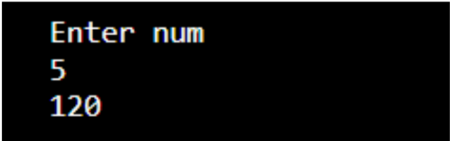

Practical : 2.3

Aim : Write a shell script to find if a given number is prime or not?

Program :

echo "enter a number"

read num

f=0

i=2

while [ $i -le `expr $num / 2` ]

do

if [ `expr $num % $i` -eq 0 ]

then

f=1

fi

i=`expr $i + 1`

done

if [ $f -eq 0 ]

then

echo "it is a prime number"

else

echo "it is not a prime"

fi

Output :

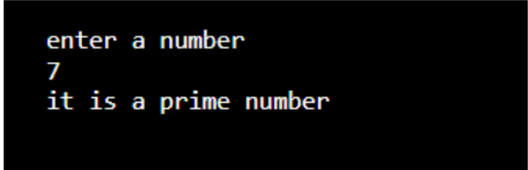

Practical : 3.1

Aim : Write a shell script to find if the given string is Palindrom or not?

Program :

echo "enter a string"

read s

echo $s > temp

rsv="$(rev temp)"

if [ "$s" = "$rsv" ]

then

echo "It is a palindrome"

else

echo "It is not a palindrome"

fi

Output :
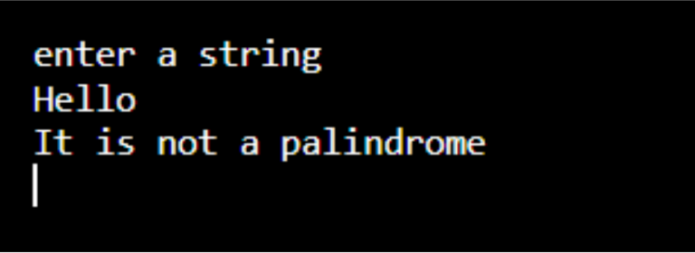

Practical : 3.2

Aim : Write a shell script to make a sum of digits of a given number.

Program :

echo "enter a number"

read num

sum=0

while [ $num -gt 0 ]

do

d=`expr $num % 10`

sum=`expr $sum + $d`

num=`expr $num / 10`

done

echo "sum of digits is $sum"

Output :-
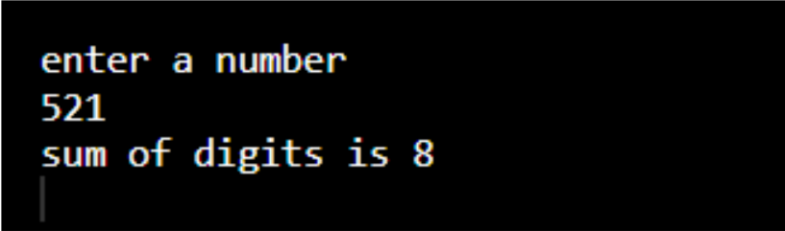

Practical 3.3

Aim : Write a shell script to read n numbers as command arguments and sort them in descending order.

Program :

[24ce114@localhost ~]$ vi sortdesc

read -p "Enter numbers separated by space: " -a nums

if [ ${#nums[@]} -eq 0 ]; then

echo "No numbers entered."

exit 1

fi

echo "Original numbers: ${nums[@]}"

for ((i=0; i<${#nums[@]}; i++))

do

for ((j=i+1; j<${#nums[@]}; j++))

do

if [ "${nums[i]}" -lt "${nums[j]}" ]; then

temp=${nums[i]}

nums[i]=${nums[j]}

nums[j]=$temp

fi

done

done

echo "Numbers in descending order: ${nums[@]}"

Output :

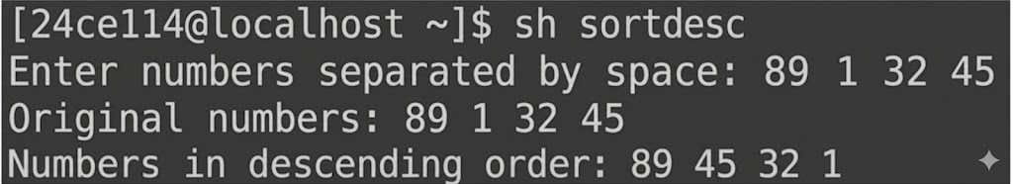

Practical 4.1

Aim : Write a shell script to find min, max, average of a given set of numbers.

[24ce114@localhost ~]$ vi minmaxavg

echo "Enter numbers separated by space:"

read -a arr

n=${#arr[@]}

sum=0

for ((i=0; i<n; i++))

do

num=${arr[$i]}

if [ $i -eq 0 ]

then

max=$num

min=$num

else

if [ $num -gt $max ]

then

max=$num

fi

if [ $num -lt $min ]

then

min=$num

fi

fi

sum=$((sum+num))

done

avg=$((sum/n))

echo "Maximum number = $max"

echo "Minimum number = $min"

echo "Average = $avg"

Output :
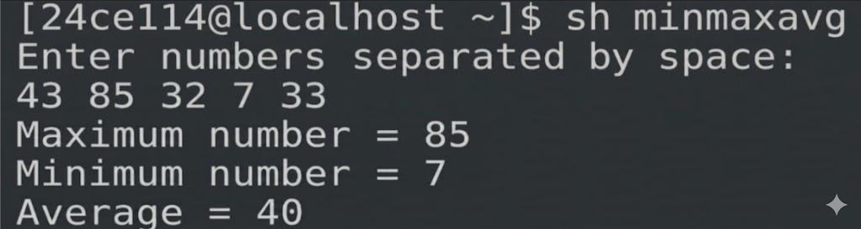

Practical 4.2

Aim : Write a shell script to complete a CD command which takes one number as argument and moves that many levels up from the current directory.

[24ce114@localhost ~]$ vi upcd

uplevel()

{

level=$1

if((level<=0)); then

echo "Enter positive number"

else

i=1

while((i<=level))

do

cd ..

i=$((i+1))

done

pwd

fi

}

echo "Enter number of levels to move up="

read num

uplevel $num

Output :
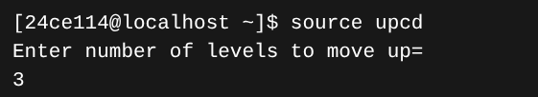

Practical 5.1

Aim : Write a shell script to mail a common message to all users who are currently logged in.

Program :

[24ce114@localhost ~]$ vi mailall

mail_all()

{

echo "Hello"

read msg

users=$(who | awk '{print $1}' | sort | uniq)

for user in $users

do

echo "$msg" | write $user

done

echo "Message sent to all logged-in users"

}

mail_all

Output :
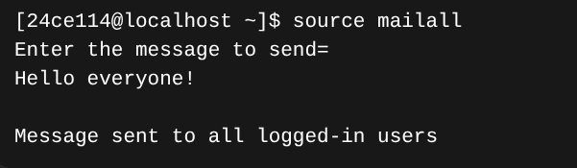

Practical 5.2

Aim : Write a shell script to display 5 largest files in the current directory.

Program :

[24ce114@localhost ~]$ vi largest5

largest_files()

{

Echo "% Largest files ="

ls -lS | head -n 6

}

largest_files

Output :
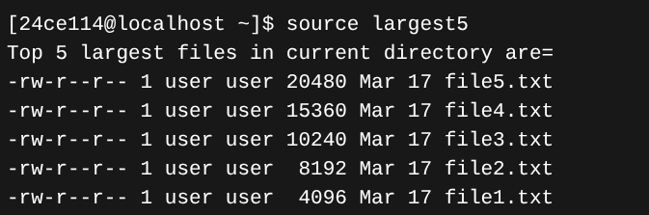

Practical 5.3

Aim : Write a shell script to count how many files in given directory.

Program :

[24ce114@localhost ~]$ vi filecount

count_files()

{

echo "Enter Directory Path : "

read dir

if [ -d "$dir" ]

then

count=$(ls -1 "$dir" | wc -l)

echo "Number of files in directory = $count"

else

echo "Invalid directory"

fi

}

count_files

Output :
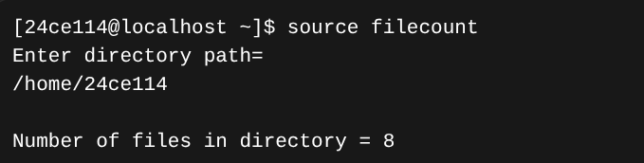

Practical 6.1

Aim : Write a shell script to translate all characters in File to upper case.

Program :

[24ce102@localhost ~]$ vi upper_case

#!/bin/bash

upper_case()

{

echo "Enter filename:"

read file

if [ -f "$file" ]; then

tr 'a-z' 'A-Z' < "$file"

else

echo "File not found."

fi

}

upper_case

Output :
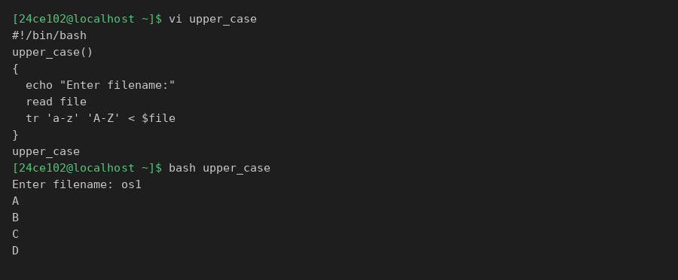

Practical 6.2

Aim : Write a shell script to change file extension (.txt) to (.doc) using for loop.

Program :

[24ce102@localhost ~]$ vi change_ext

#!/bin/bash

change_ext()

{

for file in *.txt

do

newname="${file%.txt}.doc"

mv "$file" "$newname"

echo "Renamed: $file -> $newname"

done

}

change_ext

Output :
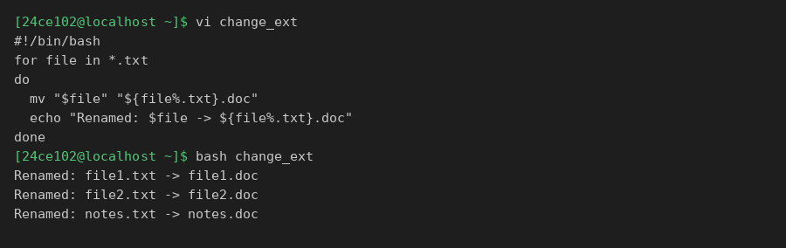

Practical 6.3

Aim : Write a shell script to compare two files to check whether they are same or not.

Program :

[24ce102@localhost ~]$ vi compare_files

#!/bin/bash

compare_files()

{

echo "Enter first filename:"

read f1

echo "Enter second filename:"

read f2

if cmp -s "$f1" "$f2"; then

echo "Files are the same."

else

echo "Files are different."

fi

}

compare_files

Output :
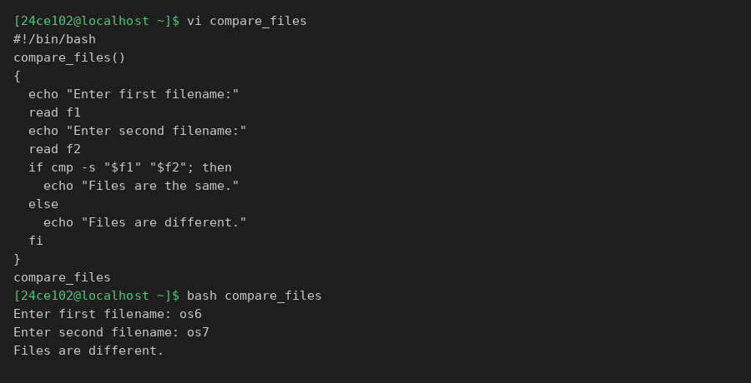

Practical 7.1

Aim : Write a C program to implement “ls” command in Linux.

Program :

#include <stdio.h>

#include <dirent.h>

#include <stdlib.h>

int main(int argc, char *argv[]) {

const char *path = (argc > 1) ? argv[1] : ".";

DIR *dir = opendir(path);

if (dir == NULL) {

perror("opendir");

return 1;

}

struct dirent *entry;

while ((entry = readdir(dir)) != NULL) {

printf("%s\n", entry->d_name);

}

closedir(dir);

return 0;

}

Output :
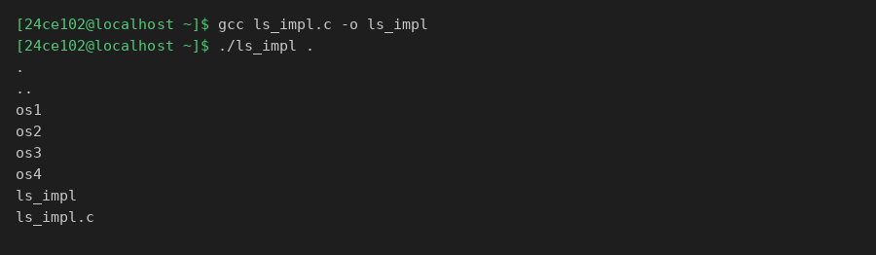

Practical 7.2

Aim : Write a C program to implement “who” command in Linux.

Program :

#include <stdio.h>

#include <utmp.h>

#include <time.h>

int main() {

struct utmp *entry;

setutent();

while ((entry = getutent()) != NULL) {

if (entry->ut_type == USER_PROCESS) {

time_t t = entry->ut_tv.tv_sec;

char *ts = ctime(&t);

ts[16] = '\0';

printf("%-10s %-8s %s\n",

entry->ut_user, entry->ut_line, ts + 4);

}

}

endutent();

return 0;

}

Output :
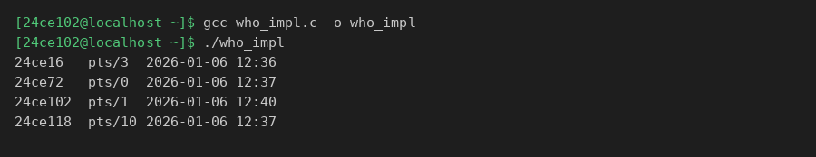

Practical 8.1

Aim : Write a C program to create exactly ‘n’ child processes with use of fork() system call in Linux.

Program :

#include <stdio.h>

#include <stdlib.h>

#include <unistd.h>

#include <sys/wait.h>

int main() {

int n;

printf("Enter number of child processes: ");

scanf("%d", &n);

printf("Parent process PID: %d\n", getpid());

for (int i = 1; i <= n; i++) {

pid_t pid = fork();

if (pid == 0) {

printf("Child %d created PID: %d\n", i, getpid());

printf("Child %d exiting.\n", i);

exit(0);

}

}

for (int i = 0; i < n; i++) wait(NULL);

printf("Parent: all children done.\n");

return 0;

}

Output :
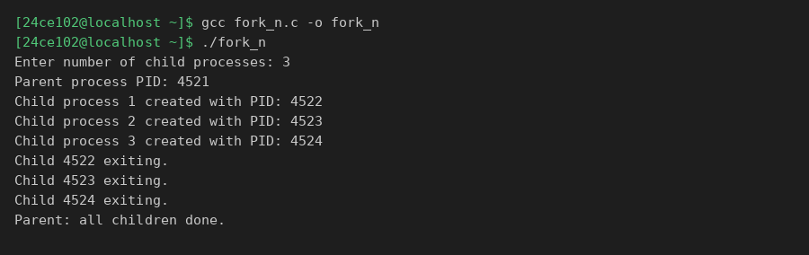

Practical 8.2

Aim : Write a C program to distribute logic/work among ‘n’ child processes created by fork() system call in Linux.

Program :

#include <stdio.h>

#include <stdlib.h>

#include <unistd.h>

#include <sys/wait.h>

int main() {

int n = 3, total = 100;

int chunk = total / n;

printf("Distributing work among %d child processes\n", n);

for (int i = 0; i < n; i++) {

int start = i * chunk + 1;

int end = (i == n-1) ? total : start + chunk - 1;

pid_t pid = fork();

if (pid == 0) {

long sum = 0;

for (int j = start; j <= end; j++) sum += j;

printf("Child %d (PID %d): sum[%d..%d]=%ld\n",

i+1, getpid(), start, end, sum);

exit(0);

}

}

for (int i = 0; i < n; i++) wait(NULL);

return 0;

}

Output :
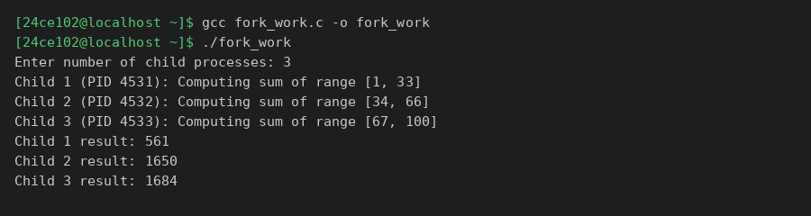

Practical 8.3

Aim : Write a C Program to create two child processes and run ‘who’ and ‘ls’ command in it with use of fork() and exec() system call.

Program :

#include <stdio.h>

#include <unistd.h>

#include <sys/wait.h>

int main() {

printf("Parent PID: %d\n", getpid());

pid_t pid1 = fork();

if (pid1 == 0) {

printf("--- Child 1 running 'who' ---\n");

execlp("who", "who", NULL);

perror("execlp who");

return 1;

}

wait(NULL);

pid_t pid2 = fork();

if (pid2 == 0) {

printf("--- Child 2 running 'ls' ---\n");

execlp("ls", "ls", NULL);

perror("execlp ls");

return 1;

}

wait(NULL);

return 0;

}

Output :
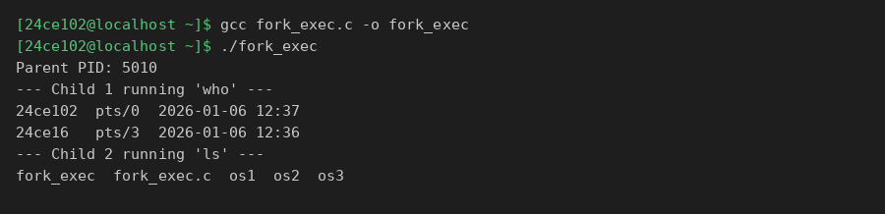

Practical 9.1

Aim : Write a C Program to create two threads for addition and subtraction of two large size array in parallel.

Program :

#include <stdio.h>

#include <stdlib.h>

#include <pthread.h>

#define SIZE 1000000

long long arr1[SIZE], arr2[SIZE];

long long add_result, sub_result;

void *add_arrays(void *arg) {

add_result = 0;

for (int i = 0; i < SIZE; i++)

add_result += arr1[i] + arr2[i];

return NULL;

}

void *sub_arrays(void *arg) {

sub_result = 0;

for (int i = 0; i < SIZE; i++)

sub_result += arr1[i] - arr2[i];

return NULL;

}

int main() {

for (int i = 0; i < SIZE; i++)

arr1[i] = arr2[i] = i + 1;

pthread_t t1, t2;

pthread_create(&t1, NULL, add_arrays, NULL);

pthread_create(&t2, NULL, sub_arrays, NULL);

pthread_join(t1, NULL);

pthread_join(t2, NULL);

printf("Addition result: %lld\n", add_result);

printf("Subtraction result: %lld\n", sub_result);

return 0;

}

Output :
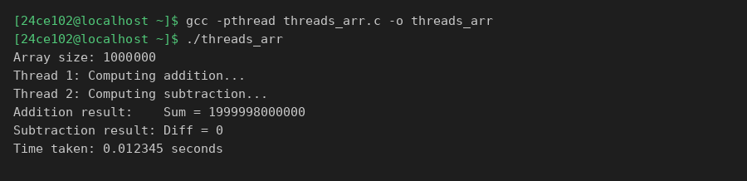

Practical 9.2

Aim : Write a C Program to create child processes for addition and subtraction of two large size array in parallel. Compare the parallelism achieved in Thread model and child Process model.

Program :

#include <stdio.h>

#include <stdlib.h>

#include <unistd.h>

#include <sys/wait.h>

#include <pthread.h>

#include <time.h>

#define SIZE 1000000

long long arr1[SIZE], arr2[SIZE], add_res, sub_res;

void *t_add(void *a){add_res=0;for(int i=0;i<SIZE;i++)add_res+=arr1[i]+arr2[i];return NULL;}

void *t_sub(void *a){sub_res=0;for(int i=0;i<SIZE;i++)sub_res+=arr1[i]-arr2[i];return NULL;}

int main() {

for(int i=0;i<SIZE;i++) arr1[i]=arr2[i]=i+1;

// Thread model

struct timespec ts, te;

clock_gettime(CLOCK_MONOTONIC, &ts);

pthread_t th1,th2;

pthread_create(&th1,NULL,t_add,NULL);

pthread_create(&th2,NULL,t_sub,NULL);

pthread_join(th1,NULL); pthread_join(th2,NULL);

clock_gettime(CLOCK_MONOTONIC, &te);

double t_time=(te.tv_sec-ts.tv_sec)+(te.tv_nsec-ts.tv_nsec)/1e9;

printf("Thread: Add=%lld Sub=%lld Time=%.4fs\n",add_res,sub_res,t_time);

// Process model

clock_gettime(CLOCK_MONOTONIC, &ts);

if(fork()==0){long long s=0;for(int i=0;i<SIZE;i++)s+=arr1[i]+arr2[i];printf("PAdd=%lld\n",s);exit(0);}

if(fork()==0){long long s=0;for(int i=0;i<SIZE;i++)s+=arr1[i]-arr2[i];printf("PSub=%lld\n",s);exit(0);}

wait(NULL); wait(NULL);

clock_gettime(CLOCK_MONOTONIC, &te);

double p_time=(te.tv_sec-ts.tv_sec)+(te.tv_nsec-ts.tv_nsec)/1e9;

printf("Process Time=%.4fs\n",p_time);

printf("Threads faster: shared memory, less context-switch overhead.\n");

return 0;

}

Output :
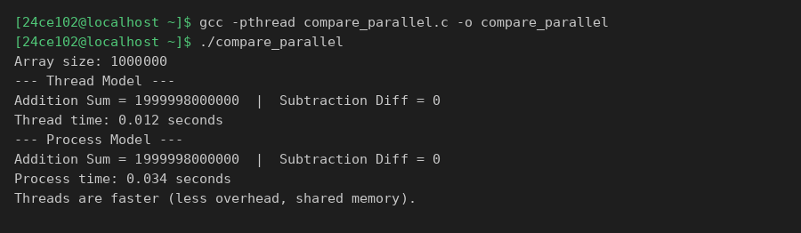

Practical 10.1

Aim : Write a C programs to demonstrate the use of shared memory variables.

Program :

#include <stdio.h>

#include <stdlib.h>

#include <sys/ipc.h>

#include <sys/shm.h>

#include <string.h>

#include <unistd.h>

#include <sys/wait.h>

#define SHM_SIZE 1024

int main() {

key_t key = 1234;

int shmid = shmget(key, SHM_SIZE, IPC_CREAT | 0666);

if (shmid < 0) { perror("shmget"); exit(1); }

char *shm = (char *)shmat(shmid, NULL, 0);

strcpy(shm, "Hello from shared memory!");

printf("Writer: '%s'\n", shm);

pid_t pid = fork();

if (pid == 0) {

char *child_shm = (char *)shmat(shmid, NULL, 0);

printf("Reader (child): %s\n", child_shm);

shmdt(child_shm);

exit(0);

}

wait(NULL);

shmdt(shm);

shmctl(shmid, IPC_RMID, NULL);

printf("Shared memory deleted.\n");

return 0;

}

Output :
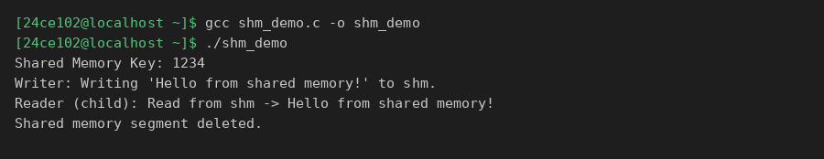

Practical 10.2

Aim : Write a C program to demonstrate and use of semaphores in Linux.

Program :

#include <stdio.h>

#include <stdlib.h>

#include <sys/ipc.h>

#include <sys/sem.h>

#include <unistd.h>

#include <sys/wait.h>

union semun { int val; };

void sem_wait_op(int semid) {

struct sembuf sb = {0, -1, SEM_UNDO};

semop(semid, &sb, 1);

}

void sem_signal_op(int semid) {

struct sembuf sb = {0, 1, SEM_UNDO};

semop(semid, &sb, 1);

}

int main() {

key_t key = 5678;

int semid = semget(key, 1, IPC_CREAT | 0666);

union semun arg; arg.val = 1;

semctl(semid, 0, SETVAL, arg);

printf("Semaphore created. Key: %d\n", key);

pid_t pid = fork();

if (pid == 0) {

printf("Process 2 (PID %d): Waiting...\n", getpid());

sem_wait_op(semid);

printf("Process 2: In critical section.\n");

sleep(1);

printf("Process 2: Leaving.\n");

sem_signal_op(semid);

exit(0);

} else {

printf("Process 1 (PID %d): Waiting...\n", getpid());

sem_wait_op(semid);

printf("Process 1: In critical section.\n");

sleep(1);

printf("Process 1: Leaving.\n");

sem_signal_op(semid);

wait(NULL);

}

semctl(semid, 0, IPC_RMID);

printf("Semaphore removed.\n");

return 0;

}

Output :
